**PROJECT TITLE : *SMART AGRICULTURE INITIATIVE***

*By – Prateek Tripathi*

*Under guidance of my MENTOR Mr. Aman &*

*CO-MENTOR* Mr. Ishan

Submitted to :- Aman Sir and Ishan sir

Submitted by : Prateek Tripathi

The project is a prototype made under the Summer Training Cum Internship Program offered by All Soft Solutions in Collaboration with IBM.

**ABSTRACT**:- *The main idea behind my SMART AGRICULTURE PROJECT is to provide maximum authority of the agricultural land in hands of FARMER.*

*My project covers a lot of aspects of the AGRICULTURAL FIELD,*

*From crop security to intruder alert to detailed analysis of the field.*

*Almost each and every task done at the agricultural field will be in sole control of the FARMER*

**INTRODUCTION** :-As the ne suggests “ SMART AGRICULTURE “ ,Everything which is being done on the agricultural field will be done in a smart way.

The farmer will have his eyes on almost each and every thing of the farm from his house.

Our farmer will be able to monitor

1. the  **moisture** content of the soil,
2. he’ll be able to monitor the  **temperature and humidity** of the soil,
3. he will be informed if there is on the farm,
4. he will be informed if **somebody is trying to roam in the**  **field**  without his permission,
5. if there is any water logging in the field our farmer will be able to move the water to a tank.

Everything mentioned above will be controlled remotely by the farmer.

**HARDWARE :-**

1. **Arduino Uno:-** The Arduino Uno is an open-source microcontroller board based on the Microchip ATmega328P microcontroller and developed by Arduino.cc. The board is equipped with sets of digital and analog input/output pins that may be interfaced to various expansion boards and other circuits.
2. **Jumper Wires :-** A **jump wire** (also known as jumper wire, or jumper) is an [electrical wire](https://en.m.wikipedia.org/wiki/Electrical_wire), or group of them in a cable, with a connector or pin at each end (or sometimes without them – simply "tinned"), which is normally used to interconnect the components of a [breadboard](https://en.m.wikipedia.org/wiki/Breadboard) or other prototype or test circuit, internally or with other equipment or components, without soldering.
3. **Power Supply Module :-** Breadboard power supply module, compatible with 5V, 3.3V. Apply to MB102 breadboard. Input voltage: 6.5-12 V (DC) or USB power supply. Output voltage: 3.3V/5V can switch over. Maximum output current: <700 ma. Fluctuation two road independent control can switch over to 0 V, 3.3 V, 5 V. On-board two groups of 3.3V, 5V DC output plug pin, convenient external lead use.
4. **Ultrasonic Sensor Module :-**  The HC-SR04 **ultrasonic sensor** uses **SONAR** to determine the distance of an object just like the bats do. It offers excellent non-contact range detection with high accuracy and stable readings in an easy-to-use package from 2 cm to 400 cm or 1” to 13 feet.
5. **Water Level Sensor :-** The **water level sensor** is super easy to use and only has 3 pins to connect. S (Signal) pin is an analog output that will be connected to one of the analog inputs on your **Arduino**. + (VCC) pin supplies power for the **sensor**. It is recommended to power the **sensor** with between 3.3V – 5V.
6. **Rain Detector :-** The rain sensor detects water that comes short circuiting the tape of the printed circuits. The sensor acts as a variable resistance that will change status : the resistance increases when the sensor is wet and the resistance is lower when the sensor is dry.
7. **Piezo Buzzer :-** A "piezo buzzer" is basically a tiny speaker that you can connect directly to an Arduino. "Piezoelectricity" is an effect where certain crystals will change shape when you apply electricity to them. By applying an electric signal at the right frequency, the crystal can make sound.
8. **PIR Motion Sensor :-** The HC-SR501’s infrared imaging sensor is an efficient, inexpensive and adjustable module for detecting motion in the environment. The small size and physical design of this module allow you to easily use it in your project.
9. **Humidity and Temperature Sensor :-** It uses a capacitive **humidity sensor** and a thermistor to measure the surrounding air, and sends a digital signal on the data pin. In this example, you will learn how to use this **sensor** with **Arduino** UNO. The room temperature and **humidity** will be printed to the serial monitor.
10. **Servo Motor :-** A **Servo Motor** is a small device that has an output shaft. This shaft can be positioned to specific angular positions by sending the **servo** a coded signal. As long as the coded signal exists on the input line, the **servo** will maintain the angular position of the shaft.
11. **Soil Moisture Sensor :-** This **sensor** measures the volumetric content of water inside the **soil** and gives us the **moisture** level as output. The **sensor** is equipped with both analog and digital output, so it can be used in both analog and digital mode.
12. **BreadBoard :-** Breadboard provides a way of constructing electronics without having to use a soldering iron. Components are pushed into the sockets on the breadboard and then extra 'jumper' wires are used to make connections.

**SOFTWARE USED :-**

Arduino IDE Software :- Arduino is an open source platform used for building electronics projects consists of both a physical programmable circuit board(often referred to as a microcontroller) and a piece of software, or IDE (Integrated Development Environment) that runs on our computers, phones and PCs are used to write and upload code to the physical board.

**Actual Setup:-**

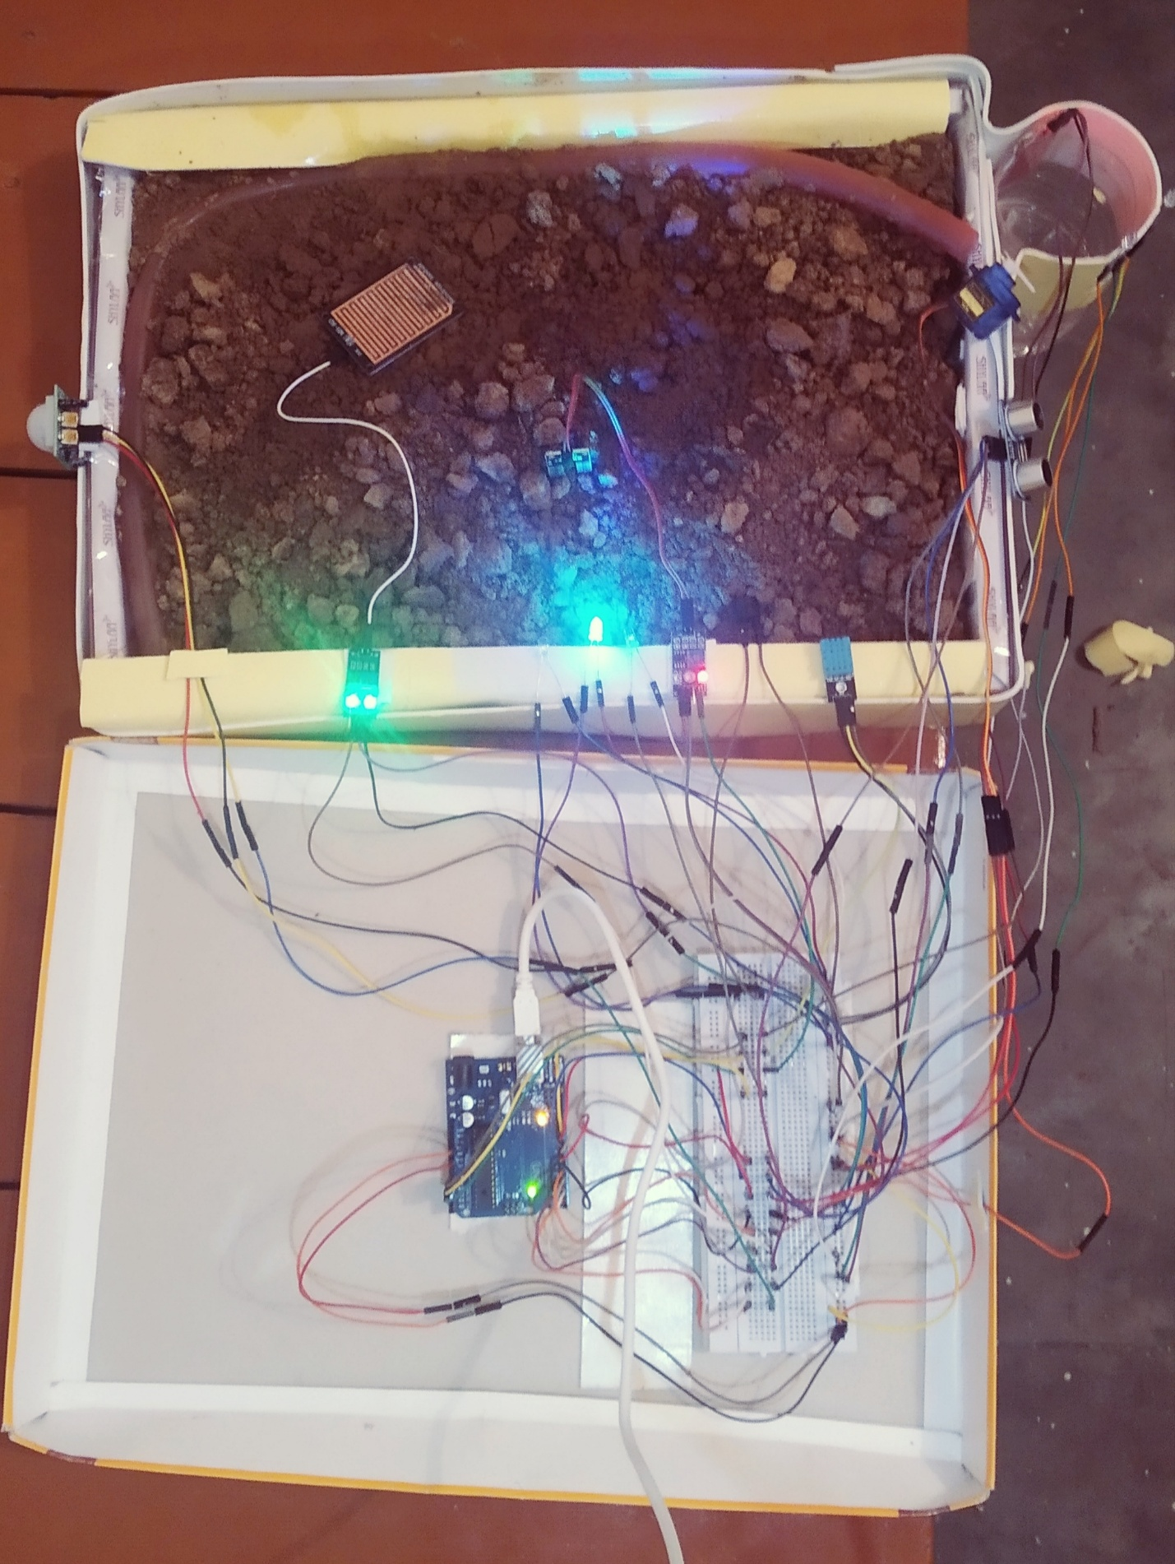

**Advantages :-**

1. It will help the farmer to remotely control the field.
2. This prototype features use of some smart sensors which will tell each and every type of data collected by the sensors…directly to the farmer.
3. It will reduce the use of human resource.
4. It will provide the data which will help the farmer to analyze the field for future predictions.
5. This project will help the future generation to implement the human force only at times when the task is not possible by machines.

**FUTURE SCOPE :-**

This project is having a huge future scope U der the aegis of the project, the worthy consumer will have a lot of positive results.

Since farming is the only means to fill up our tummy and we also know that, not everyone is interested in farming.

Through this setup, the farmer will definitely have a huge profit and this will also attract the youth towards the farming job.

Since a lot of things are made easier for the farmer, so there shall be minimal human intervention which will save a lot of money which would have been given to the labourers.